syst 17796 Deliverable 1

design document template W2022

# Overview

## Project Background and Description

Describe the project goals and final vision. Include a brief description of how to play the game you have chosen and a reference to the rules of the game you have chosen.

Each player must be dealt seven cards face-down.

Place all of the remaining cards face-down to form a draw pile. Next, take the top card from the draw pile and place it face-up nearby to begin the discard pile. With both the draw and discard piles in place, you are ready to begin. Generally, the player to the dealer’s left will go first. However, you may also choose a player to begin or select the youngest player, oldest player, etc. This card game has a clockwise turn rotation. After the first player has finished their turn, the player to their left will begin theirs. When playing Uno, your goal will be to rid yourself of your cards as quickly and efficiently as possible. The only way to score points and ultimately win the game is by being the first player to run out of cards. To do this, you will need to play cards from your hand to match the number, color, or the action of the top card in the discard pile. You may also play a wild card to alter the color that is currently in play. if a Skip card is in play, your turn will be skipped. If a reverse card is in play, you will play your turn as usual, but then the game will begin to progress counter-clockwise instead of clockwise.

Describe the names and roles of each team member. Describe the technical scope of the project by talking about the interface and how you will know when the project is complete.

## High-Level Requirements

|  |  |
| --- | --- |
|  | [Describe the high level requirements for the project. For example:] |

The new system must include the following:

* Ability for each player to register with the game
* Ability for the game to communicate a win or loss
* Ability for players to know their status (score) at all times

## Implementation Plan

Include your Git repository URL here and a brief description of the expected use (i.e. each developer checks in code at the end of each day/week). Text files are stored under a separate directory, code, UML diagrams have their own folders etc.

Include information on coding standards you intend to follow and tools you expect to use (VP, NetBeans, eclipse, Junit…)

## Models

* Create a Use Case diagram to illustrate the functional requirements of the system,
* Create a Domain Class Diagram to illustrate the key classes your system will have and their relationships

|  |  |  |
| --- | --- | --- |
| Register | external | The user registers to the server. |
| Connects and login | external | After registering the user connects to game server and login |
| Start game | external | The user starts the game using start button |
| Initialisation by server | internal | The server initialises the game and plays with the user |
| Color request | temporal | The user requests a color |
| Draw card | temporal | The user draws the next round of cards |
| Mix card | internal | The game server mixes the card randomly |
| Declaring winner | Temporal | The winner is displayed by saying Uno at the end |
| Get statistics | Temporal | The player wants to know the cards left and other statistics, so the administrator gets those stats from the server and this is viewed by player |

Events

Use case

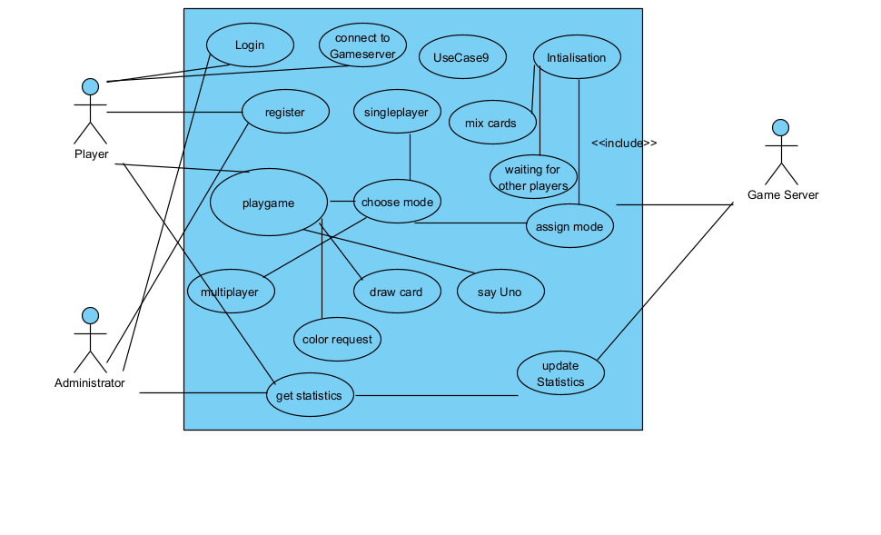

Domain Class Diagram

